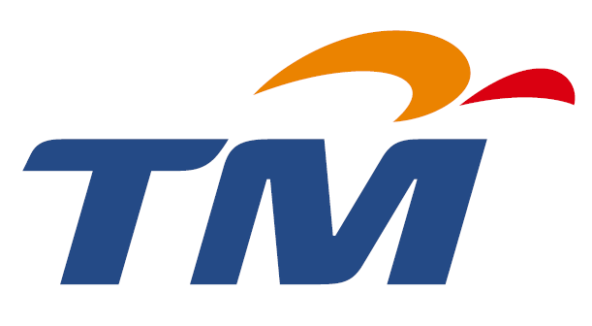

TELEKOM MALAYSIA BERHAD (128740-P)
(Incorporated in Malaysia)

RESOLUTION PROPOSED AND DULY PASSED AT THE EXTRAORDINARY GENERAL MEETING OF TELEKOM MALAYSIA BERHAD
HELD ON 16 MAY 2006

ORDINARY RESOLUTION

EMPLOYEES SHARE OPTION SCHEME FOR ELIGIBLE DIRECTORS AND EMPLOYEES OF DIALOG TELEKOM LIMITED (FORMERLY KNOWN AS mtn networks (PRIVATE) LIMITED), TM’S SUBSIDIARY, AND ITS ELIGIBLE SUBSIDIARIES

THAT the establishment of the employees share option scheme (“Dialog ESOS”) for eligible Directors and employees of Dialog Telekom Limited (formerly known as MTN Networks (Private) Limited) (“Dialog”), TM’s subsidiary, and its eligible subsidiaries (“Dialog Group”) under which options will be granted to eligible Directors and employees of the Dialog Group to subscribe for ordinary shares of Rs1 each in Dialog, in accordance with the Bye-Laws of the Dialog ESOS as set out in Appendix I of the Circular to shareholders dated 29 April 2006, be and is hereby approved and ratified;

AND THAT TM’s Board of Directors be and are authorised to approve any modifications and/or amendments to the Dialog ESOS from time to time provided that such modifications and/or amendments are effected in accordance with the provisions of the Bye-Laws of the Dialog ESOS and to do all such acts and to enter into all such transactions, arrangements, agreements, deeds or undertakings and to make rules or regulations, or impose such terms and conditions or delegate part of its powers as may be necessary and/or expedient in order to give full effect to the Dialog ESOS.

